Module A: Speed Test

模块A：速度测试
Web Technologies

网站技术

Submitted by:
Thomas Mak
David Cantwell
Chorng-shiuh Koong
Siew Hwa Kang
Seunglyul Ryu
Bruno Medeiros
Gilles Granger
Ryoju Ohata
Zhang Ling

Contents内容
Contents内容 2
Introduction介绍 3
Part A A部分 3
A1: Masking Image (Easy)掩蔽图像（简单） 3
A2: Vectored artwork (Normal)矢量图（普通） 3
A3: Double Exposure Effect (Easy)双重曝光效果（简单） 3
A4: Instagram Grid (Normal)Instagram网格（普通） 4
A7: Apply Background (Easy)应用背景（简单） 4
A8: Add a filter (Easy)添加一个过滤器（操作简单） 4
Part B B部分 6
B3: 9-Images (Medium)9图像（中等难度） 6
B7: Korean flag (Normal)韩国国旗（普通） 6
B8: Rotating Star (Easy)旋转星（简单） 7
B10: 5 Stars Rating Animation (Easy)5星评级动画（简单） 7
B13: Accessibility (Medium)可访问性（中） 8
Part C C部分 9
C2: Spotlight (Medium)聚光灯（中） 9
C4: Notebook (Difficult)笔记本（困难） 9
C16: Drawing tool (Medium) 绘图工具（中） 10
C25: Mouse style (Easy)鼠标样式（简单） 11
Part D D部分 12
D7: Number of Days (Easy)天数（简单） 12
D15: Write a Secure Login (Difficult)编写安全登录（困难） 12
Part E E部分 13
E8: Modal POST (Difficult) 模态POST（困难） 13
E12: Change Login path (Easy) 更改登录路径（简单） 13
Instructions to the Competitor 选手须知 14
Equipment, machinery, installations, and materials required 所需设备，机器，装置和材料 14
Marking Scheme 评分方案 14

Introduction 介绍
In this speed test project. You only need to complete the randomly picked one during the competition. Please follow the instruction to know which one to implement.在这个速度测试项目中。你只需要在比赛期间完成随机选择的一项。请按照说明了解要完成哪一项。
For each Easy, it worths 0.5 point. 每个Easy值0.5分。
For each Medium (Normal), it worths 1 point.每个中等（普通）值1分。
For each Difficult (Hard), it worths 1.5 point.对于每个困难（困难），它值1.5分。
Please put your files in /XX_module_a/ and with the task ID as folder name, e.g. /XX_module_a/A1/请将文件放在/XX_module_a/中，并将任务ID作为文件夹名，例如/XX_modele_a/A1/
The XX is the workstation number.
XX是工作站编号。

Part A A部分

A1: Masking Image (Easy)

掩蔽图像（简单）
Open the provided image (flower.jpg) in an image editor and change the image into greyscale. Once completed, you need to mask the flower and place it on the background image (background.jpg) provided. Save your new image as XX_A1.psd and XX_A1.jpg
在图像编辑器中打开提供的图像（flower.jpg），并将图像更改为灰度。完成后，您需要遮罩花朵并将其放置在提供的背景图像（background.jpg）上。将新图像保存为XX_A1.psd和XX_A1.jpg

A2: Vectored artwork (Normal)

矢量图形（普通）
Create the following icons with reference to the image provided (icons_sample.jpg).
Icons should be recreated as a vectored artwork. Once completed, save your working file as XX_A2.ai and XX_A2.jpg 参照提供的图像（icons_sample.jpg）创建以下图标。
图标应重新创建为矢量化的艺术品。完成后，将工作文件保存为XX_A2.ai和XX_A2.jpg

A3: Double Exposure Effect (Easy)

双重曝光效果（简单）
Create a similar double exposure effect as in the example below. Save a JPEG file called double-exposure.jpg.
创建类似的双重曝光效果，如下例所示。保存名为double-exposure.jpg的JPEG文件。
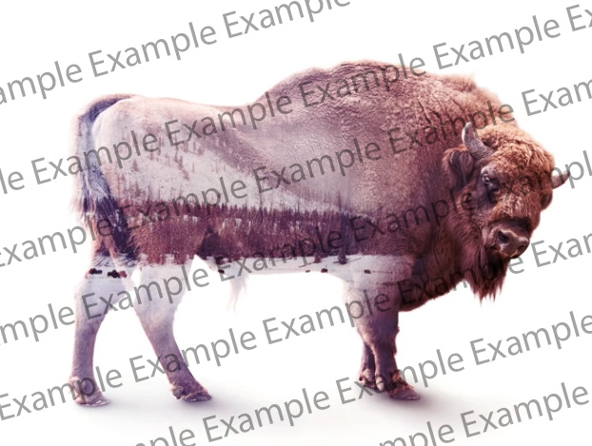

A4: Instagram Grid (Normal) Instagram网格（普通）
Add a profile pic (profile-pic.jpg), username(pedro.souza), and add 9 pics in the feed in the Instagram Grid mockup (Instagram-Profile-2022.psd) and then put it into the iPhone mock (iphone-mock.jpg). Save the output into a JPEG file called instagram-grid.jpg
添加一个配置文件图片（profile pic.jpg）、用户名（pedro.souza），并在Instagram Grid mockup（Instagram-profile-2022.psd）的feed中添加9张图片，然后将其放入iPhone mock（iPhone mock.jpg）。将输出保存到名为Instagram-Grid.jpg的JPEG文件中

A7: Apply Background (Easy) 应用背景（简单）
Apply the background image 2.jpg to the image 1.jpg
将背景图像2.jpg应用于图像1.jpg
- Submit as result.jpg. (0 points when using sample.jpg from the media file)
- 提交为result.jpg。（使用媒体文件中的sample.jpg要判为0分）

1.jpg + 2.jpg | Result = sample.jpg
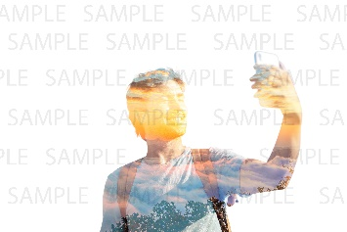


A8: Add a filter (Easy) 添加过滤器（简单）
- Add a noise filter to the image plane.jpg. Submit as result.jpg. (0 points when using result.jpg)
- 将噪波过滤器添加到image plane.jpg。提交为result.jpg。（使用result.jpg会被判为0分）
plane.jpg | result.jpg
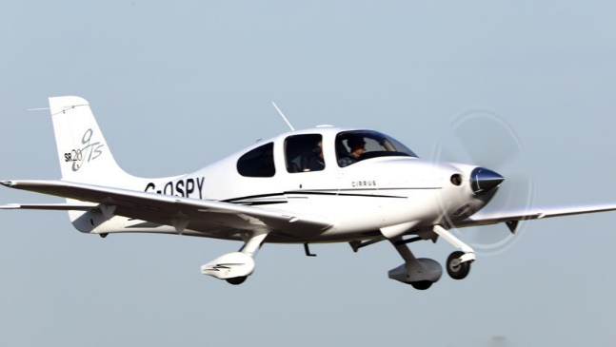 | 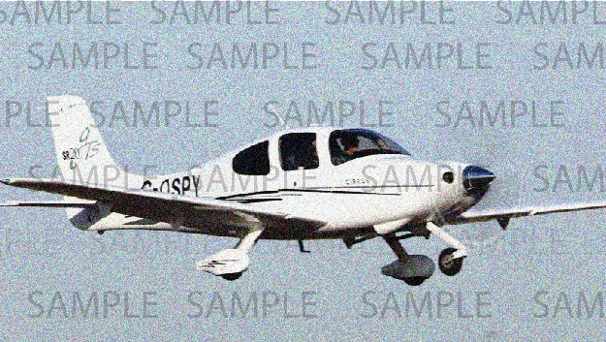

Part B

B3: 9-Images (Medium)

B3:9-图像（中等难度）
Create an image grid container using CSS only. The maximum capacity of the container is 9. If the number of images is overload, the number of excess-images is displayed in the last grid.
仅使用CSS创建图像网格容器。容器的最大容量为9。如果图像数超载，则在最后一个网格中显示多余的图像数。
You can only edit the style.css file.
只能编辑style. css文件。
Tips: the “Remove First Image” button is the function provided.
提示：“删除第一个图像”按钮是提供的功能。
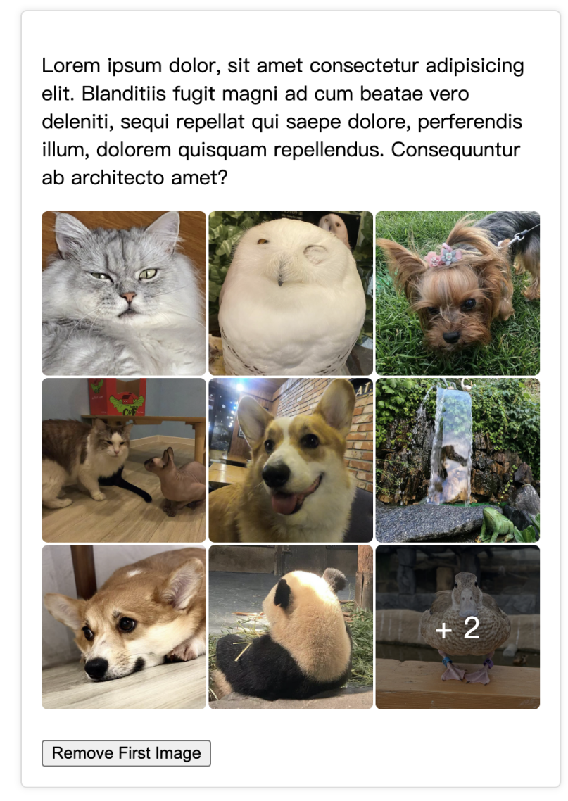

B7: Korean flag (Normal) 韩国国旗（普通）
Please, write the CSS code to create the korean flag like the one you can see here.
(No media files)
请编写CSS代码来创建如下所示的韩国国旗。（无媒体文件）



B8: Rotating Star (Easy)旋转星形（简单）
Please, draw a yellow rotating five-pointed star using CSS.
(No media files) 请用CSS画一个黄色的旋转五角星。
（无媒体文件）

B10: 5 Stars Rating Animation (Easy)五星评级动画（简单）
Create a 5 Stars Rating UI using the provided "stars.png" image. (Use HTML/CSS only)使用提供的“Stars.png”图像创建一个五星评级用户界面。（仅使用HTML/CSS）
When you hover your mouse over a star, an animation that smoothly fills in from the left to the star's score proceeds.
当您将鼠标悬停在星星上时，动画将从左边平滑填充到星星的分数。
Score 0.5 point unit: 0, 0.5, 1, 1.5, 2, 2.5, 3, 3.5, 4, 4.5, 5
得分0.5分 单位：0、0.5、1、1.5、2、2.5、3、3.5、4、4.5、5
Example实例


Refer to animation.mp4 for the star filling animation.
关于五星填充动画，请参阅animation. mp4。

B13: Accessibility (Medium)可访问性（中等）
Any time you are developing a web site or web application you should ensure you follow any applicable guidelines for accessibility. This will help ensure it can be used by people with disabilities including visual disability.
在开发网站或web应用程序时，应确保遵循任何可访问性适用准则。这将有助于确保残疾人（包括视力残疾者）可以使用它。
You have been provided with a single HTML page named accessibility.html in the provided-assets folder that has five common accessibility issues. Your task is to identify and implement a fix for these issues.
已经提供的资源管理文件夹里包含一个名为accessibility.html的单一HTML页面。文件夹里有五个常见的可访问性问题。您的任务是确定并修复这些问题。
Save your solution as accessibility-fixed.html inside of a new folder.
将解决方案保存为accessibility-fixed.html，放在一个新文件夹里。

Part C

C部分

C2: Spotlight (Medium)

C2：聚光灯（中等）
Referring to the given media, you are required to show a spotlight over an image when the mouse moves over the image. The spotlight should be white in color, translucent, and has some blur effects. When you move the mouse wheel up or down, the size of the spotlight will increase or decrease respectively. Your program should detect a minimum size of 10px for the dimension of the spotlight. At all times, ensure that the mouse cursor is in the middle of the spotlight.
参考给定的媒体，当鼠标移动到图像上时，需要在图像上显示一个聚光灯。聚光灯应该是白色、半透明的，并有一些模糊的效果。当你上下移动鼠标滚轮时，聚光灯的大小将分别增大或减小。你的程序应该检测到聚光灯维度的最小尺寸为10px。在任何时候，都要确保鼠标光标位于聚光灯的中间。

C4: Notebook (Difficult)

C4：笔记本（困难）
You should develop based on a page which is provided in media files. Develop a function when you click the “Render” button, the selected text should be marked(“yellow” background and “red” foreground),and when you mark other text, the previously marked text should be retained.
你应该基于媒体文件中提供的页面进行开发。当你点击“渲染”按钮时，选定的文本应该被标记（“黄色”背景和“红色”前景），当你标记其他文本时，应该保留之前标记的文本。
You can only edit “index.js” file.
你只能编辑“index.js”文件。
You can not use JavaScript libraries.
你不能使用JavaScript库。
Select Text:
选择文本：
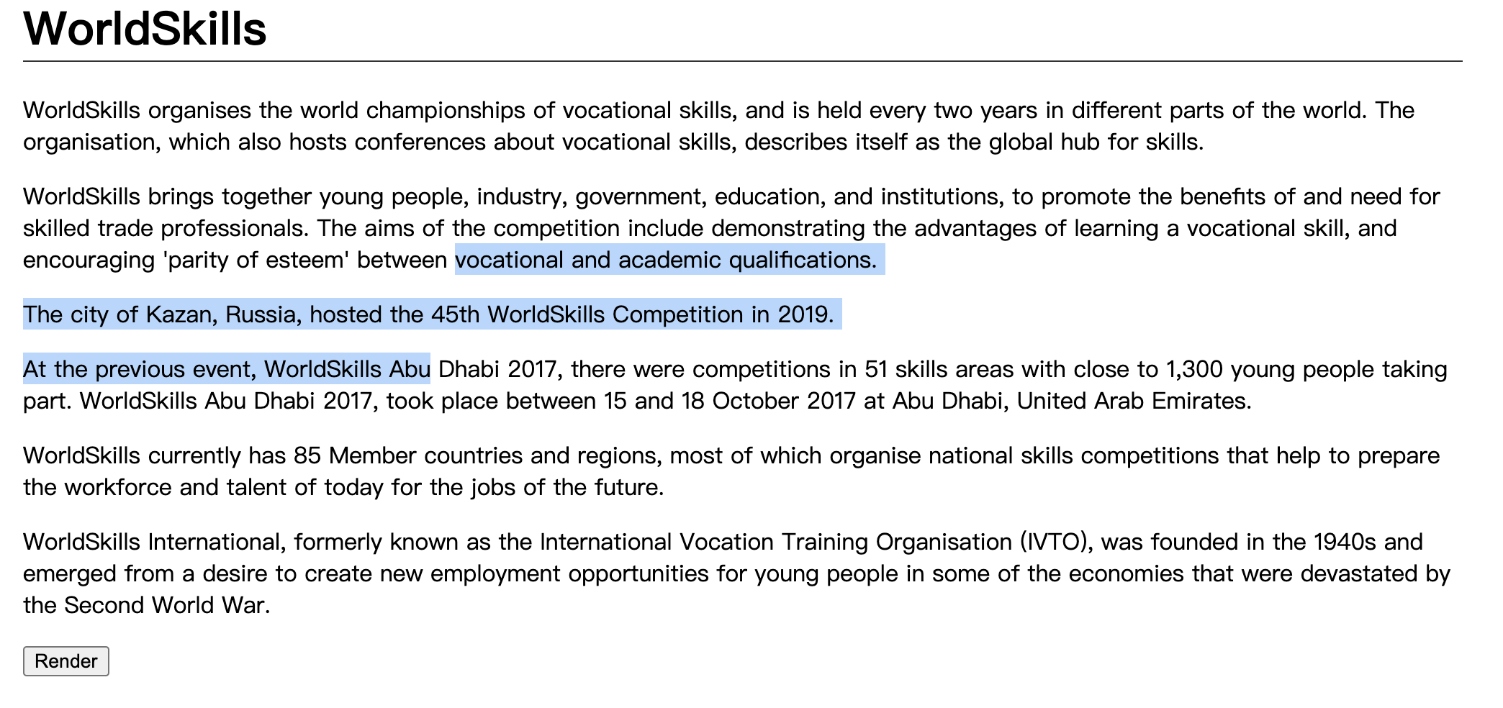
Mark Text:
标记文本：
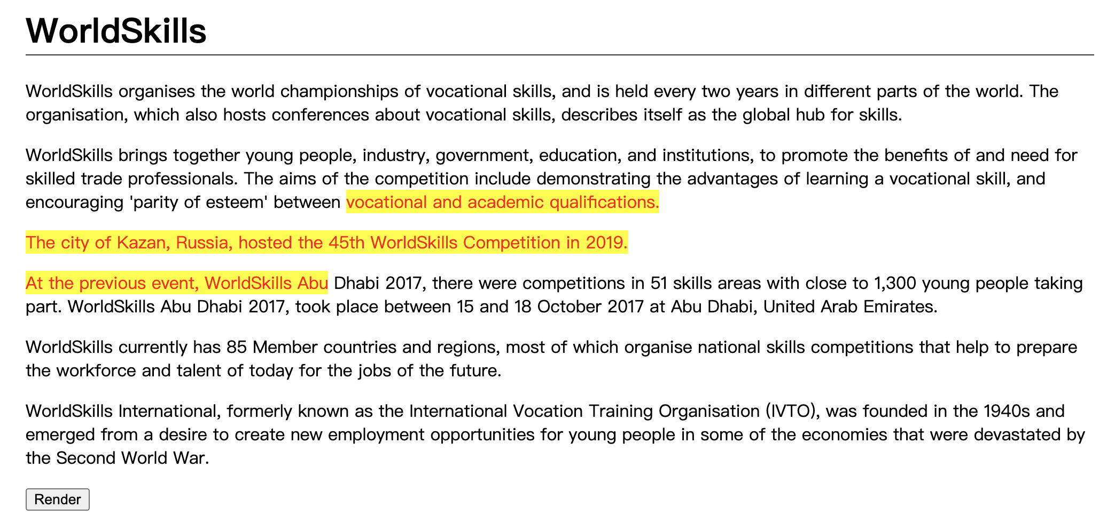
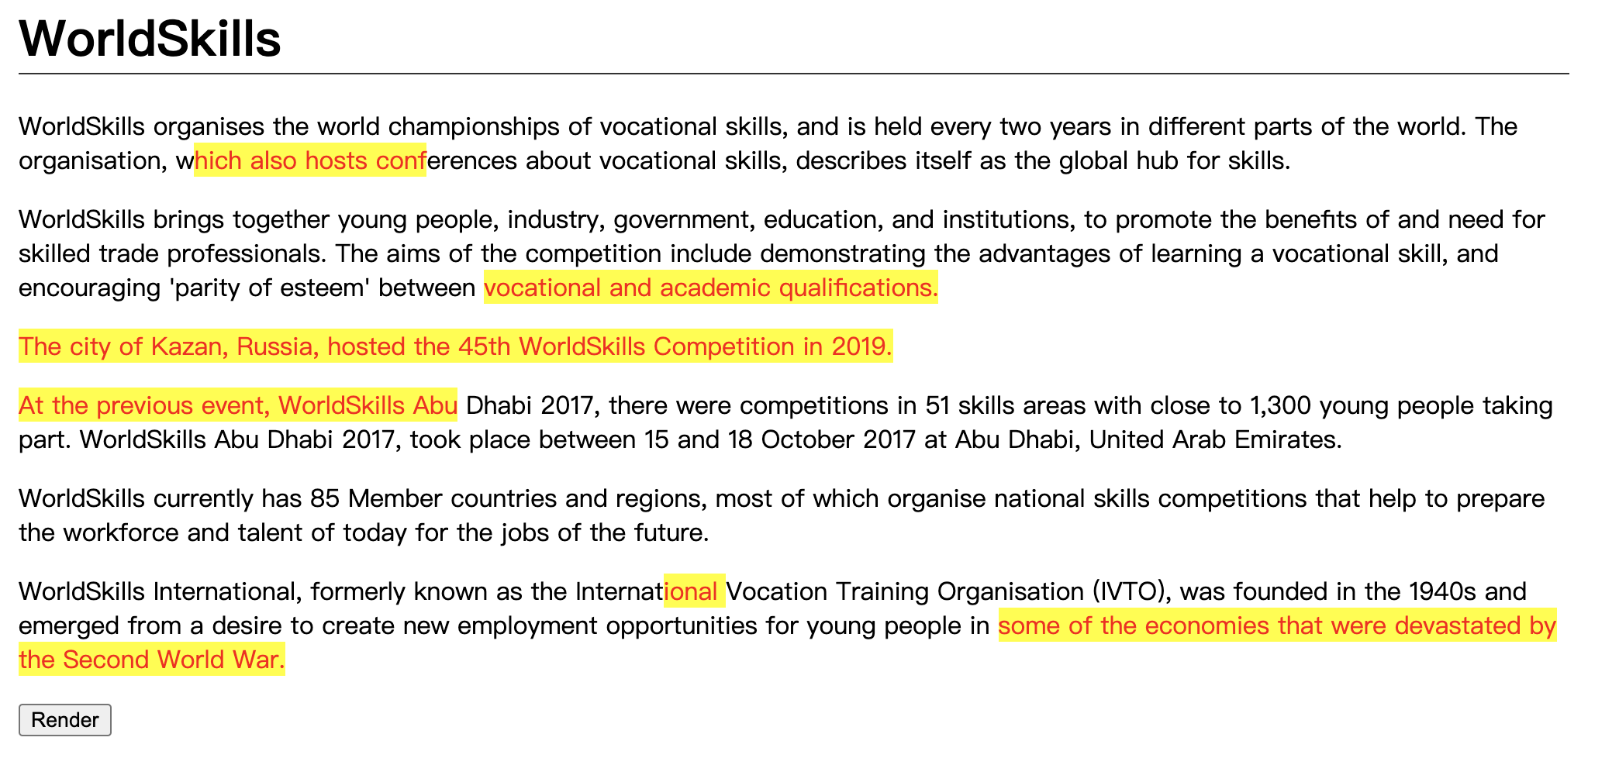

C16: Drawing tool (Medium)

C16：绘图工具（中等）
You are to create a client-side drawing tool, with a canvas on which one may freely draw.
你要创建一个客户端绘图工具，其中有一个画布，人们可以在上面自由绘画。
- Five different colour buttons are to be provided for the user to select from
- 提供五个不同颜色的按钮，供用户选择
- The default canvas size is to be 300px by 300px
- 默认的画布大小是300px乘300px
- Clicking and dragging the bottom-right corner of the canvas is to modify the canvas size
- 单击并拖动画布的右下角，可以修改画布的大小
- 1 button to save the drawing as a jpg and 1 button to save the drawing as a png onto the client-side computer are to be provided
- 提供1个将图形保存为jpg的按钮，以及1个将图形作为png保存为客户端计算机的按钮
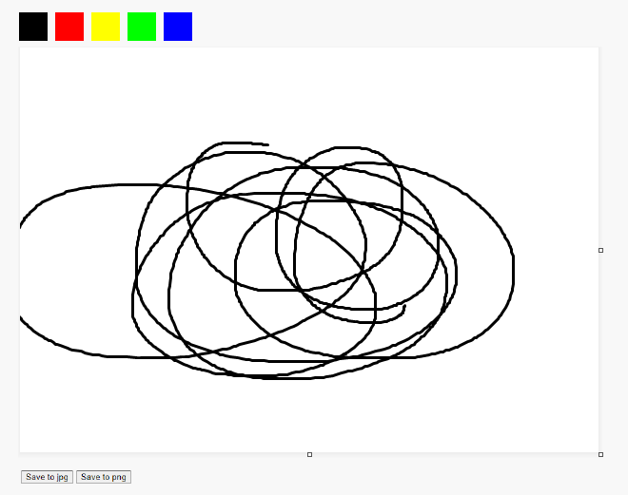

C25: Mouse style (Easy)

C25：鼠标样式（简单）
Change the style of the mouse.
改变鼠标样式。
- When clicked, it should display an animation.
- 点击时，它应该展示一个动画。
See mouse.mp4 in the given folder to understand the functionality.
参阅给定文件夹中的mouse.mp4，以了解其功能。


Part D

D部分

D7: Number of Days (Easy)

D7：天数（简单）
Show the number of days between two given dates. The user must enter as data in the input date. The date is in YYYY-MM-DD (ISO8601) format.
显示两个给定日期之间的天数。用户必须在输入日期中输入作为数据。日期为YYYY-MM-DD（ISO8601）格式。
Input: index.php?date1=1992-07-19&date2=1992-07-22
输入：index.php?date1=1992-07-19&date2=1992-07-22
Output: 3 days
输出：3 days

D15: Write a Secure Login (Difficult)

D15：编写安全登录（困难）
Security is a key consideration when writing web applications. In this task, you are provided with a small website that includes an authentication system. However, upon reviewing this code you notice several issues including:
安全性是编写网页应用程序时的一个关键考虑因素。在此任务中，将提供给你一个包含身份验证系统的小网站。然而，在查看此代码时，你会注意到几个问题，包括：
- Passwords are stored in plain text
- 密码以纯文本的形式存储
- Cookies contain information about the user
- 缓存中包含有关该用户的信息
- There is no accommodation for SQL injection attacks
- SQL注入攻击没有空间
- There is no accommodation for brute force attacks
- 暴力破解攻击没有空间
- No feedback is provided to the user on bad logins
- 没有向用户提供关于不良登录的反馈
Your task is to fix the highlighted issues with the existing system to make it more secure.
你的任务是修复现有系统中突出显示的问题，以使其更安全。
You have been provided with a basic user table for your database, but you will need to add fields to implement your updates.
为你的数据库，已经提供给你一个基本的用户表，但你将需要添加字段来实现你的更新。
The functionality for checking if a user is logged in as well as handling the login request is also provided but is also insecure.
还提供了检查用户是否登录以及处理登录请求的功能，但也是不安全的。
When you are finished, please ensure you provide the judges with valid login information for your secure website!
当你完成后，请确保你提供给评委有效登录信息，登录你的安全网站！

Part E

E部分
When creating database, please name your db speed_test_EX, where X is the task number. Please use username: admin, password: admin for all the tasks in part E. If we cannot login to check, mark is deducted.
在创建数据库时，请命名db speed_test_EX，其中X是任务编号。请在E部分所有任务中使用用户名：admin，密码：password。如果我们不能登录上去检查，会扣分。

E8: Modal POST (Difficult)

E8：模态POST（困难）
Create a theme where you can create a customizable header and also where you can display all posts and when you click view post a floating window will appear with the content of the post.
创建一个主题，在那里你可以创建一个可定制的标题，也可以显示所有的帖子。当你点击查看帖子时，一个浮动窗口将出现与帖子的内容。
- See theme_post_modal.mp4 in the given folder as an example.
- 以给定文件夹中的theme_post_modal.mp4为例。

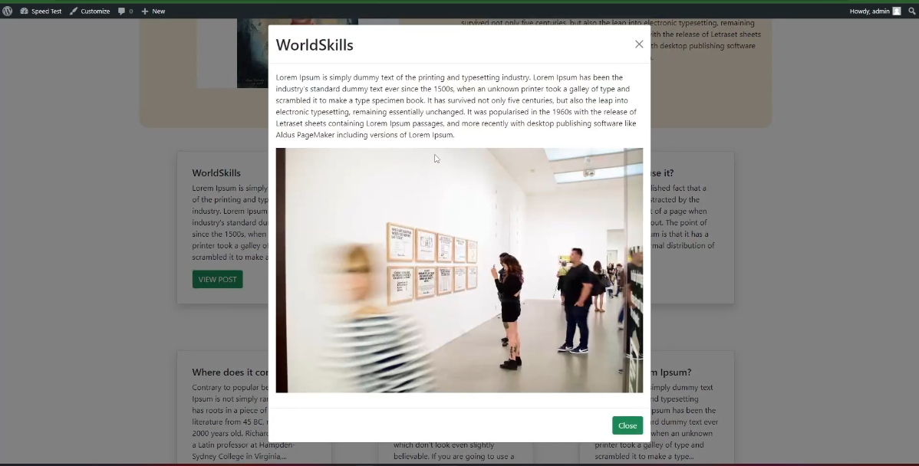

E12: Change Login path (Easy)

E12：更改登录路径（简单）
Change the wp-login.php into member-login.php and keep the Wordpress login still working as usual.
将wp-login.php更改为member-login.php，并保持Wordpress登录仍然正常工作。

Instructions to the Competitor

选手须知
- Please ensure your name the files according to the description and organize your files for assessment.
- 请确保你根据描述命名好了文件，并整理好文件准备评估。
- All assessment is done on server. No assessment process in workstation.
- 所有的评估都是在服务器上完成的。工作站内无评估流程。

Equipment, machinery, installations, and materials required

所需的设备、机器、装置和材料
ITEM内容 | quantity数量 | material材料 | description描述 | notes备注
- | - | - | - | -

Marking Scheme

评分方案
 |  | Communication and Presentation | Design | Layout | Front-end | Back-end | CMS | Total
A1 | Design | 0.5 | 4 | - | - | - | - | 4.5
A2 | Layout | - | - | 4 | - | - | - | 4
A3 | Front-end | - | - | - | 4 | - | - | 4
A4 | Back-end | - | - | - | - | 2 | - | 2
A5 | CMS | - | - | - | - | - | 2 | 2
 | Total |  |  |  |  |  |  | 16.5

 |  | 交流与呈现 | 设计 | 布局 | 前端 | 后端 | CMS | 总分
A1 | 设计 | 0.5 | 4 | - | - | - | - | 4.5
A2 | 布局 | - | - | 4 | - | - | - | 4
A3 | 前端 | - | - | - | 4 | - | - | 4
A4 | 后端 | - | - | - | - | 2 | - | 2
A5 | CMS | - | - | - | - | - | 2 | 2
 | 总分 |  |  |  |  |  |  | 16.5

